Year 12 ATAR PHYSICS
Practical Test WAVES AND QUANTA

Part B: DETERMINING THE EFFECTIVE WAVELENGTH OF A LED.

Marks: /10

ANSWERS

The threshold voltage at which a semiconductor LED turns on gives a measure of the bandgap or emission wavelength of the LED through the following relationship:
The following circuit was constructed:
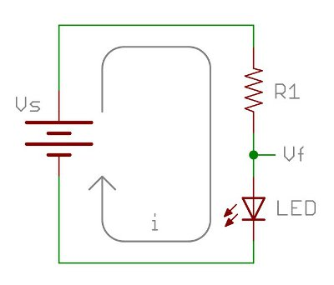
V
100 Ω resistor

50K Rheostat
A
By adjusting the rheostat, the following values of current and voltage through the LED was recorded:
V(V) | I(mA)
2.40 | 0.12
2.43 | 0.40
2.44 | 0.50
2.48 | 0.97
2.50 | 1.20

Question 1
Plot a suitable graph of the results. ( 4 marks)
- Labels (1) appropriate scales (2) accurate plotting (-1 if scale inappropriate and LOBF too steep)

mA
1.2

1.1

1.0

0.9

0.8

0.7

0.6

0.5

0.4

0.3

0.2

0.1

0

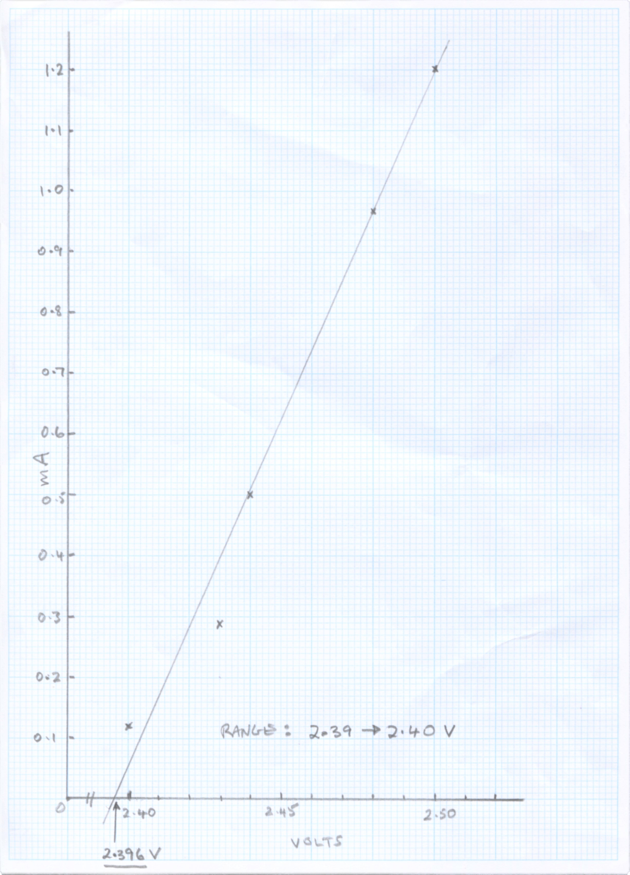

x
x
x
x
x
Range: 2.39 - 2.42
2.40 2.45 2.50
2.395
Question 2 ( 3 marks)
Determine the threshold voltage from the graph. Clearly show your method on the graph.
(1) Method shown
V_{th} = 2.39V to 2.42V (1) (0 above or below)
Answer to 3 or 4 sig figs (1)

Question 3 ( 3 marks)
Determine the wavelength of the LED in nanometres.

= hc / eV_{th}
= 6.63 x 10⁻³⁴ . 3 x 10⁸ (1)
1.6 x 10 ⁻¹⁹ . 2.395
= 5.19 x 10⁻⁷ m
= 5.19 x 10² nm (3 sig figs)
- (1)

Note for example: 519nm 3 sig fig OK
520 nm only 2 sig fig -1

